|  |  |  |
| --- | --- | --- |
| University of Central Lancashire Logo | **School of Engineering and Computing** | **Coursework Cover Sheet**  **Final Report** |

*Students should add this coversheet, to the start of their assessment before submission through Turnitin.*

| Module Tutor: Javad Yazdani | |
| --- | --- |
| Module Title: Projects  CW2 | Programme Title:  BEng EERE |
| Module Code: EL3995 | Year of Study: 2023/2024 |
| **Machine Learning in Urban Agriculture** | |
|  | |

***Academic Misconduct / Plagiarism Declaration***

By attaching this front cover sheet to my assessment I confirm and declare that I am the sole author of this work, except where otherwise acknowledged by appropriate referencing and citation, and that I have taken all reasonable skill and care to ensure that no other person has been able, or allowed, to copy this work in either paper or electronic form, and that prior to submission I have read, understood and followed the University regulations as outlined in the Academic Integrity Policy and Procedure for Academic Misconduct available at the following link: <https://www.uclan.ac.uk/study_here/assets/assessment_handbook_2122.pdf>

| **Have you checked the following in order to maximise the grade you can achieve for this assignment?** | **Please mark X to confirm** |
| --- | --- |
| Learning Outcomes have been addressed | x |
| Similarity check via Turn-it-in |  |
| Referencing accuracy according to provided guide | x |
| Grammar | x |
| Spelling | x |
| Word count (or other length limitation as described in the brief) | x |

**WELLBEING**

|  |  |
| --- | --- |
| We wish to support any student who is experiencing mitigating circumstances which prevents students from performing to the best of their ability when completing or submitting assignments. If you are experiencing such circumstances, then you may apply for mitigating circumstances**.** Wherever possible this must be done prior to handing your assignment. | I believe **that I do / I do not need** to apply for mitigating circumstances for this assignment at this moment in time  Please **delete** as appropriate  (You may still apply for mitigating circumstances if you subsequently feel that your performance has been adversely affected by issues that you may currently be unaware of). |

**Student Name William Robert Bianchi**

**Student G number 20925612**

Signature

Supervisor Name Stephen Sigurnjak

Moderator name



Machine Learning in Urban Agriculture

EL3995: Project Report

William Robert Bianchi

**Abstract**

Machine Learning application are essential for developing smart systems that can assist in several different types of tasks, object detection and classification in real-time offers opportunities for applications of machine intelligence to be used to improve efficiency of task or to automate tasks. urban agriculture involves having a condensed farm or crop area that would need to be monitored closely as any disease or infestation can spread fast and ruin a harvest. Using machine learning as quality control can be done using object detection, allowing for assisted analysis of a crop giving an accurate result to a user who might not be familiar to the crop as a professional in agriculture opening the doors to more urban based farming projects.

**Introduction**

Machine learning in Urban Agriculture, the aim of this project is to research the field of urban agriculture and apply machine learning methods to automate and improve the processes of quality control for lesser experienced farmers. This Will be completed by producing a model that can detect external damages like rotting and maturity of a common crop such as a tomato that is found in most urban farms. With Urbanization and Housing demand, farming land is slowly being reduced, this is where urban agriculture can be applied by place greenhouses and orchards within cities will increase food production within communities and reduce import greenhouse gas emissions. Machine Learning can be applied to urban Agriculture too flag diseases or harvestable yield so unskilled workers or users of the Urban farm have a tool to highlight harvestable and dangerous crop in turn increasing the reliability of urban farms. Through this report the techniques and methods will be displayed to show how an efficient object detection model can be trained and optimized for low memory applications like single board computers. It will also show the effect that the Tensor processing unit has on the frame rate of real time inferencing, it will compare the use of the central processing unit to the Tensor processing unit.

Table of Contents

|  |  |
| --- | --- |
| Topic | Page number |
| Introduction | 1 |
| Literature Review | 2-3 |
| Aims and Objectives | 3 |
| Background | 3-5 |
| Methodology | 5-9 |
| Results and Analysis | 9-11 |
| Improvements for Future study | 11 |
| Reference list | 12-13 |
| Appendix | 13-21 |

**Literature Review**

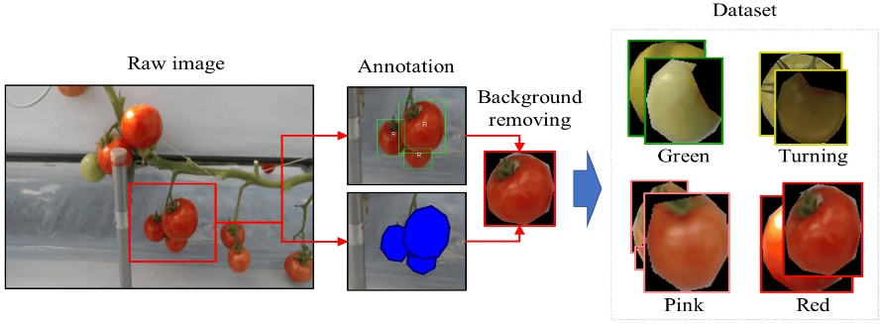Machine learning in Agriculture: a Review The authors cover Disease detections and examples of what methods have been used to detect diseases within crops. As The most significant concern in agriculture is pest and disease control ([Dimitrios Moshou,2018](https://www.mdpi.com/1424-8220/18/8/2674)) the Article covers a multitude of crops ranging from rice too wheat and strawberries, this also includes the diseases and pest that commonly effect these crops such as the detection of nitrogen stressed and yellow rust infected wheat crops([Dimitrios Moshou,2018](https://www.mdpi.com/1424-8220/18/8/2674)). This article is beneficial too the project as it covers a range of techniques and is not biased towards one certain machine learning method or specific crops. A More in depth examination of machine learning in agriculture is shown By [Kim .T(2022)](https://www.mdpi.com/2076-3417/13/1/412) within the article they cover how using machine learning and image processing of hues of a tomato, the maturity of the crop can be determined by the hue of the skin of the fruit. [Kim.T(2022)](https://www.mdpi.com/2076-3417/13/1/412) shows that images processing can improve the output of the machine learning model, they show that by selecting the colour of the fruit and then removing the background to highlight the fruit resulting in a clearer result. The image provided in the article shows the application of the image processing. In this example uses a Deep Neural Network, they are relatively and new technology that uses multiples processing layers to learn complex data representation[(Patrizia Busato,2018)](https://www.mdpi.com/1424-8220/18/8/2674). [Tillet,R.D(1991)](https://www.sciencedirect.com/science/article/abs/pii/B9780323905084000071?via%3Dihub) states the issues with lighting in an agricultural environment too produce an accurate image where there is high contrast., the author suggests in an lab environment back lighting would produce the best image for computation but in actual environment omnidirectional lighting would be more fitting for the situation, the application of using lighting on the product produced within this project. Furthermore [Tillet,R.D(1991](https://www.sciencedirect.com/science/article/abs/pii/B9780323905084000071?via%3Dihub)) continues to suggests converting the image into a binary image, this would turn the image into only black and white 1 being white and 0 being black. Brighter colours would be set as 1 and the darker 0 so you can focus on the subject, this would not work well in project as it needs to classify hues of skin for fruit.

During the process of the report several resources were drawn upon for reference and support in completing the project.Chapeter 6 of ‘Pratical Deep learning for cloud,Mobile and Edge written by Anirudh Koul, Siddah Ganju and Meher Kasam covers a practical application based understanding of Tensorflow and how to optimize the model, they further explain quantizing and its benefits.Coral offers GitHub repositories which includes example and deployment guides written by Jonnala,H ,Brooks,M and Wang,M they give example on how to train and deploy certain application of TPU based systems this assisted in understanding how python recasts and can be used to manipulate the object detector. Tensor flow offers a Colab notebook that went through how to train and produce a TFlite Model but did not convert to TPU and had not been updated for new libraries and capabilities of the current tensorflow, Evan Juras produced a notebook that was updated to be compatible with the newer versions of TensorFlow and the requisites packages such as the TFLite converter and the TPU compiler. Evan Juras also explained how to test the model and what was occurring in the model which allowed me to further research the background of each piece of hardware and the converters in detail. Furthermore this covers the compilation of the TFLite model into an understandable graph for the TPU[Evan,J]. specifications for the hardware were acquired directly from Raspberry Pi as they have an extensive library of documentation covering specifications, libraries and more [Raspberrypi] this allowed for study of the CPU and understanding the single board computers capabilities and how the libraries can interact.

**Aims and objectives**.

The aim of this project was to produce a custom trained object detection model that can run on a single board computer and interact with peripherals and record the findings of the object detection model. The crop selected was tomatoes as this is a common all around the world, the aim of the machine learning is to detect 3 different states of a tomato these being unripe, fresh and rotten. This project will display methods of labelling data and train a TensorFlow Lite Model which will be converted to run on Edge TPU Hardware. Throughout the project the objective was to explore areas of machine learning and seeing how this can be applied into an agricultural environment. Using a combination of hardware this project will display the ability to run machine learning object detection running in real time on a single board computer like the raspberry pi. Having machine learning on a single board computer can show how ai solutions can be mad affordable when in comparison to large computation systems, it also means that the application can be in a small form factor.

**Background**

Agriculture is the practice of farming which includes cultivation of soil for growing crops, Urban agriculture is placing Orchards, community gardens and Planters within Urban areas with the purpose of increasing localized crop yields, produce a more sustainable city and reduce carbon dioxide levels within a city. The outcome of this project will be to produce the software and hardware that would allow for the application of machine learning object detection against common crops that would be seen in urban Orchards. As urban sprawl continues the UK is reducing the amount of space for farmland by building housing estates and extending cities. This is where urban agriculture needs to be implemented for 3 main Reasons, firstly Urban farms allow for higher biodiversity within cities secondly the production of food within cities will lower the amount of imported goods needed within a city, finally it will help reduce greenhouse gas as plants photosynthesize, they take in carbon dioxide and produce oxygen in exchange [(Brinkley, C and S. Kingsley, J (2016)](https://www.sciencedirect.com/topics/agricultural-and-biological-sciences/urban-agriculture) .

Machine Learning Focuses on self-improving algorithms that learn from “Experience”, This Experience is a data set that is curated for a specific task in the case of this project the data set will consist of labeled images of a defined crop including variation of the image including diseased and unripe. Machine learning tasks are classified into two categories of training, supervised and unsupervised. Supervised training is where data is presented with the output and inputs labeled and it then maps inputs to outputs. False positives and false negatives can occur during this training but a method to avoid this Is by using reinforcement learning this is where you provide a bias to a certain result training the model too further understand that something should be present or isn’t present([Dimitrios Moshou,2018](https://www.mdpi.com/1424-8220/18/8/2674)). Machine Learning in agriculture is a subject that has ongoing developments as technologies improve whether it is new image processing or new algorithms that can be applied to predict crop growth. Two common approaches of machine learning include object detection and classification of weeds and crop quality. Weed detection has a high importance within agriculture and machine learning allows for the discrimination of crops from weeds with a high accuracy rate. Crop quality is as equally as important as this uses the same classification but looks for inconsistencies and compare a subject against a perfect input and whether the crop would meet certain standards this means a decrease in waste and increase in efficiency ( [Dimitrios Moshou,2018](https://www.mdpi.com/1424-8220/18/8/2674)). Machine Learning takes a lot of computational power and requires fast processing and object detection requires fast refresh rates for live video feed. To achieve this the project will use a Tensor Processing Unit. A tensor Processing Unit is a matrix Processing Unit specialized for neural network Workloads (Google Cloud, 2018). Edge TPU is designed to be a coprocessor to accelerate ML inferencing on devices running on low power.

An application for machine learning in agriculture is quality control understanding a crops current state can be complicated unless you have a trained eye, with the assistance of machine learning the quality of food produce can be checked by unskilled.

Tensor processing unit is a specialized hardware accelerator designed by google, it is designed to accelerate machine learning by handling large-scale parallelism and perform computations on large tensors. The TPU is optimized for tensor operations, this is vital to the execution of deep neural networks. The architecture of the TPU consists of processing cores organized into multiple matrix multiplication units (MXUs) and vector units. MXUs are designed for dense matrix multiplications. This is fundamental to deep learning operations; vector units perform element-wise operations and vector-matrix multiplications which are common in activation functions and other neural network operations. The TPU has its own instruction set architecture built for tensor operation allowing for efficient execution, the ISA has specialized instructions for matrix multiplication, vector operations and activation functions. TensorFlow XLA compiler (accelerated linear algebra) optimizes the graphs this allows for execution on the TPU. The TPU was suited for this task as image detection requires as this use convolutional neural networks (CNN), these networks involve large scale matrix multiplication which the TPU is designed to complete [Google cloud]. The Edge TPU is a purpose-built hardware accelerator designed to inference machine learning tasks at the edge, the Edge being directly on IoT devices, embedded systems and more. The TPU is fully integrated with TensorFlow lite which is a lightweight version of TensorFlow specifically designed for machine learning on edge devices. The TensorFlow lite model must be compiled and optimized to run on the hardware [Coral.ai]. The hardware opens new possibilities with IoT applications having machine learning capabilities.

The Coral TPU development board is a single board computer designed and produced by google. It incorporates the previously stated TPU on to an adaptive platform that can be used to interface with peripherals. The Coral Development board includes the Edge TPU system-on-module, the board provides all the peripheral connection needed to communicate with sensors, motors and more, it has USB3.0 ports, DSI display interface, CSI-2 camera interface and a 40 pin I/O header. The coral development board has a Linux Mendel operating system, this is a Debian derivative. The board also has a main system-on-chip (i.MX8M) which has Quad symmetric Arm cortex-A53 processors, plus Cortex M4F. the TPU interfaces with the iMX8M using PCIe and I2C/GPIO[Coral.ai].

Coral TPU USB accelerator is the same TPU as the development board but instead of it being limited to the system it is integrated into it can be communicated via USB 3.0 protocol and used alongside other devices. The benefit of this is it does not have to use Linux Mendel. It can be used alongside the operating system of choice and can be easier to implement with more openly available devices such as the Raspberry Pi.

Raspberry Pi 4 Model B is a single board computer key features being quad-core Cortex-A72(ARMv8) 64bit System-on-chip, the version used in this project had 4GB of LPDDR. The raspberry pi 4b has 2 USB 2.0 ports and 2 USB 3.0 ports along with a 40pin GPIO header. The raspberry Pi has its own operating system ‘Raspbian’ this is an OS based on Linux Debian made for the raspberry pi, this operation system has several different versions the version used in this project is Raspbian buster this is due to the compatibility with hardware and version of python. The Raspbian operating system comes preloaded with software, including the Geany IDE this is a python development environment that was used in this project to analyses and modify code to fit the needed preferences for the project. The Raspberry pi also has a CSI camera connecter that can be used to connect the pi cam module to the single board computer, the raspberry pi camera module 3 was used, along with a USB Camera as there was version clashes with the camera and the Operating system used in this project.

**Methodology**

Hardware setup initially the coral Development board was the computation device used within this project, due to the difficulty to get support for the camera and to find a coral camera module available for purchase the project now used the raspberry pi 4 b. the raspberry pi needs to have a flashed Operating system on a micro-SD card, the first OS that was boot loaded on to the raspberry pi was the latest version of Raspbian (Bookworm). Bookworm being the latest iteration the assumption would be that everything would have support for this OS however the coral and TensorFlow libraries needed for the project were not supported by the newer version of python that is on the bookworm operating system.

Collection of data, initially data was going to be collected in person however tomato is a seasonal crop and data collection did not align to this season. To remedy this online resources were used to curate images of fresh, unripe and rotten tomatoes. For object detection a range of data is needed around labeled images minimum for accurate results. Within the data set used for this project are 618 images curated using ‘FATKUN’ web extension that allows for batch downloading of images. Once these images are curated, they must be labeled, labeling is the method of applying meta data too images.’ Lableimg’(<https://pypi.org/project/labelImg/> ) is the software used for labelling for this project it uses the pascal VOC method this uses XML files to store the meta data on the image including the denoted class, the location of the drawn box and the image that it is connected to. Lableimg is an open-source tool written in python it is also capable of YOLO and CreateML formats I chose to use the PASCAL VOC as XML is easy to interpret and check for any classification errors and can be rectified using a text editor. After the data is labeled, it can then be converted into TFrecords using Roboflow an online machine learning tool for dataset augmentation and conversion. The conversion had to be made due to compatibility issues with converting using code. Roboflow allows for dataset augmentation this is important to add more variety of images and making the images more applicable to the scenario by digital altering them, the augmentations used on the data were brightness, Saturation, blur and flip/rotations. The reasoning behind the augmentations is to digitally impose flaws on to the image and as these were from the internet they were high quality images but in a real-world application it would not be the case, the most important augmentation was the brightness as greenhouse have a lot of light reflection causing them to be bright and the model should still be able to detect the tomato in those situations. Tfrecord is a simple format of storing sequence of binary records created by the data. [TensorFlow]

Training the model, training the model was done using a pre-built architecture that is then trained to your specifications, the model used in the report was MobileNetSSDv2. The model has 267 layers and 15 million parameters. The model provides real-time inference while under computation constraints making this ideal for smaller devices. MobileNetSSDv2 once trained can be stored with 63MB of storage meaning it can be used with low memory applications. [RoboFlow] the MobileNetSSDv2 Architecture is essentially a 2-part model, the first section of the model is the base MobileNet network that acts as a feature extractor for images whereas the SSD layer classifies the image. The training was completed in google Colab, this is a cloud-based notebook software that gives access to a GPU to compute heavy loads such as training the model. The Colab notebook utilizes python code, the notebook was written originally by Evan Juras he covers how to train and deploy the model also covers some testing. The code provided allows for custom settings to be used such as changing the configuration of the model, the default settings for the model training were used due to time constraints however two different models were tested. Originally the model Efficient-det0 model was chosen. However, this model would output an error during training and would have a total loss of 1.07 showing poor predictions so the MobileNetSSDv2 was used. The training configuration can be found in the appendix. 40,000 steps are suggested. The batch size determines how many images are used per step, 16 images are used for SSD models and the use of a GPU will speed up this process, the training can take around 3 to 5 hours using the GPU runtime on Colab. During the training it can be monitored using a tensor board, this allows for monitoring of the learning rate and the loss throughout the process of training. Figure 1 represents the loss against the number of steps, this graph reaches 26k steps just more than halfway through due to a runtime disconnect this is not complete. However, it clearly shows that the more steps the predictions become better initially the loss was above 0.5 this is bad as it can be a 50/50 prediction, but the prediction become better as the training proceeds the loss becomes lower. The decline on the graph shows the training is working as the predictions become better and more accurate. Learning rate changed throughout the training this ensure a more accurate model as the learning rate was low initially stared low then increase rapidly and then as more steps go, figure 2 shows how the learning rate changes throughout training as it quickly peaks at a 0.08 and then steadily declines along with the loss. When you compare figure 2 to figure 1 you can see the trend that around 2k steps which is where the learning rate peaked is where the loss reduces drastically.

Figure 1

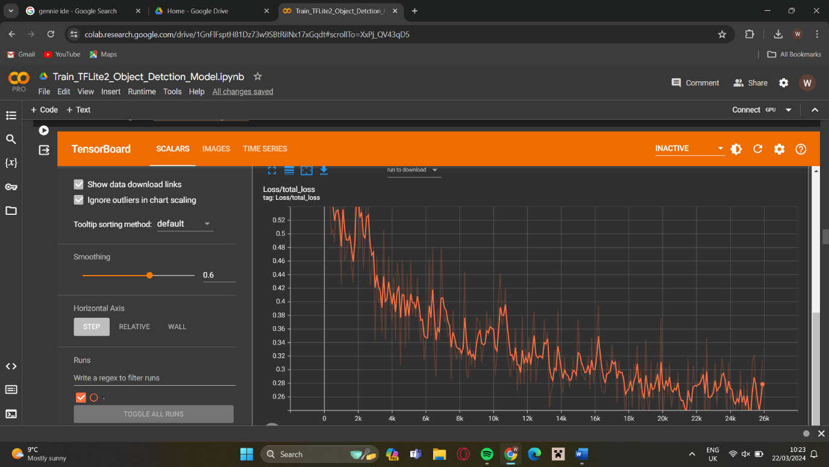

Figure 2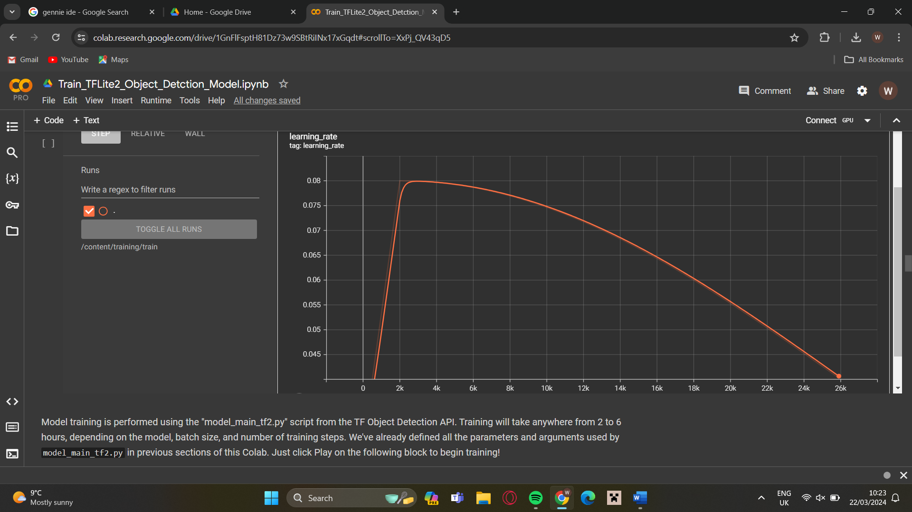

After initial training the model is tested against a test set of images and inferences them image 1 shows a test image with bounding box around the predicted class.

Image 1

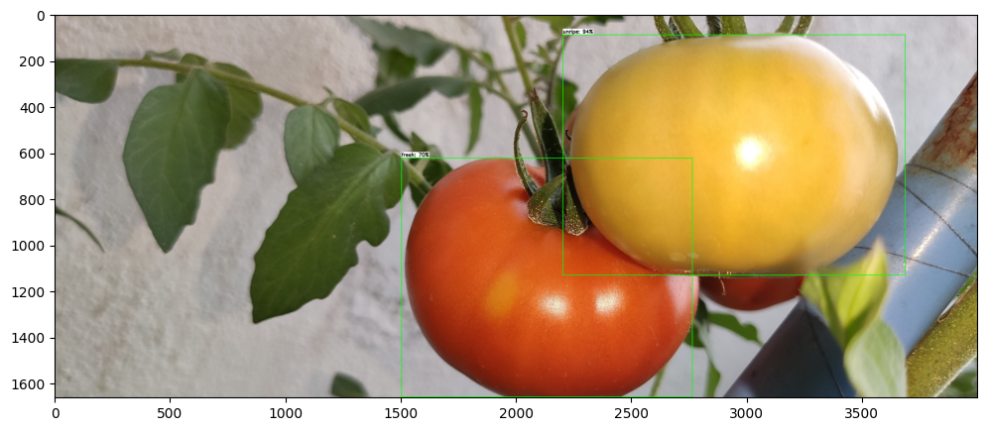

This image shows the model predicting a fresh and unripe tomato correctly. This test set is separate from the training to not overfit the model and cause it to be trained to only recognize the images that it was trained on. For the model to work efficiently on the hardware the model must quantize, quantizing allows the model to run faster, it does this by reducing the weights. The weights of the post trained model will be 32-bit floating point values after quantizing the weights will be 8-bit integer values [Koul, A., Siddha Ganju and Meher Kasam], not only does this speed up the model’s runtime it also decreases the amount of memory the model occupies without reducing the accuracy. To quantize the model, it needs to be a tensorflow lite model. This is done using the TensorFlow lite converter API. For the model to run on the Tensor flow processing unit it must be complied for the new instruction set and hardware capabilities, the compiler is provided by google and can be also run in the google Colab notebook. Testing the accuracy of model once produced, producing a confusion matrix a confusion matrix is comprised of the results from inferencing taking the true positive, true negative, false positive and false negative. Take a number for each of these in the tested images and place them on the matrix using this matrix the precision and the recall of the model.

|  |  |  |
| --- | --- | --- |
|  | Positive | Negative |
| Positive | True positive | False Positive |
| Negative | False Negative | True Negative |

|  |  |  |
| --- | --- | --- |
|  | Positive | Negative |
| Positive | TP=42 | FP=10 |
| Negative | FN=13 | TN=6 |

The confusion matrix above is produced from 50 images tested using the quantized model. To find the precision of the model the equation TP/TP+FP to find recall the equation is TP/TP+FN the results for this were.

* Precision = 0.807
* Recall = 0.764

The results will always be in between 0-1, 0 being it always gets it wrong 100% of the time and 1 being it is perfect. 0.5 score would mean that is a 50/50 on whether it is a certain class, the score must be above 0.5 for it to have a good accuracy for prediction. F1 score is a means average of precision and recall giving a value for the performance of the classification model.

*F*1=2×Precision+Recall/Precision×Recall = 0.785

The equation above shows how to calculate the f1 score using the precision and recall calculated from the confusion matrix. The F1 score produced was 0.785, the score represents the accuracy of the model it is not a perfect score but a score that represents that majority of the predictions are correct. The reason for this inaccuracy will be due to dataset if the data was curated in the environment and physically generated the accuracy of the dataset may have been superior. Another reason for this could be that the configuration during training could have been optimised maybe increasing the number of steps or increasing the batch size to predict more images in the step. The learning rate of the model changes throughout the training the changes might have decreased the accuracy of the model.

After the testing and accuracy calculations the model now needs to be deployed, this is done by exporting the model and putting it into the directory of the virtual environment on the raspberry pi, the purpose of the virtual environment is so that all dependencies can be installed and not effected by other installations. Python code provided by Tensorflow on their GitHub have been used to deploy the model, the code which is in the appendix on the report deploys the model and takes the frame from the live video captured by the webcam. Each frame is then inferenced through the model and then a box is drawn on the video around the detected object using coordinate data found from inferences this then labels the box with the class and the confidence score of the model. The code will output to the terminal with the class and the score of confidence, it only does this when the confidence score is above 80% confirming the accuracy of the model. This shows that the code is capable of outputting or performing a task depending on the viewed class.

**Results and result analysis**

When testing the model, the focus was ensuring the model was fast but still accurate. The model was test running on both the CPU of the Raspberry Pi and the TPU USB accelerator connected to the RPI, the reason for this is it displays clearly the impact that the tensor processing unit has on the efficiency of the system and clearly shows that an Machine learning system can run Realtime inferencing and still be a compact size allowing it to be put in applications such as greenhouse quality control without reducing crop space. The testing subject were on stalk cherry tomatoes in two colours one red to represent fresh tomatoes and yellow to represent unripe, however those tomato is technically not unripe and are fresh just have a different colour of ripe. To test for rotten would require a rotten sample this unfortunately was not possible to acquire, so instead a marker was used on the skin to simulate the colour differentiation from fresh skin and rotten skin of the tomato, in future testing rotten tomatoes must be tested to confirm the validity of the object detection model. As for this test it was to focus on how the different processing units performed object detection using a custom-built model. The images below show testing the model with fresh tomatos in image 2 is being ran off the Raspberry Pi CPU and is running at 2.50 fps and is not running the compiled TPU TFLite graph it is running the quantized TFLite model. It is detecting 3 of the 4 tomatos on that stalk 2 of which have a confidence greater than 90 an the other still above 70, however the image 1 on the left is showing the same test subject but being inferecend using the TPU. The TPU test image shows the frame rate of 20.47 almost 10 times the frame rate of the other test on the CPU this shows how much more fater then model can be ran without slowing down the system, however it is only detecting 1 tomato with a lacking confindence of 71%. This is a dissapointing result as the drop in accuracy is major and it is undable to detec the other classes and is only looking at 1, this might actulally by caused by the run speed an is trying to infere the frames too fast and not having an accurate evaluation of the images.

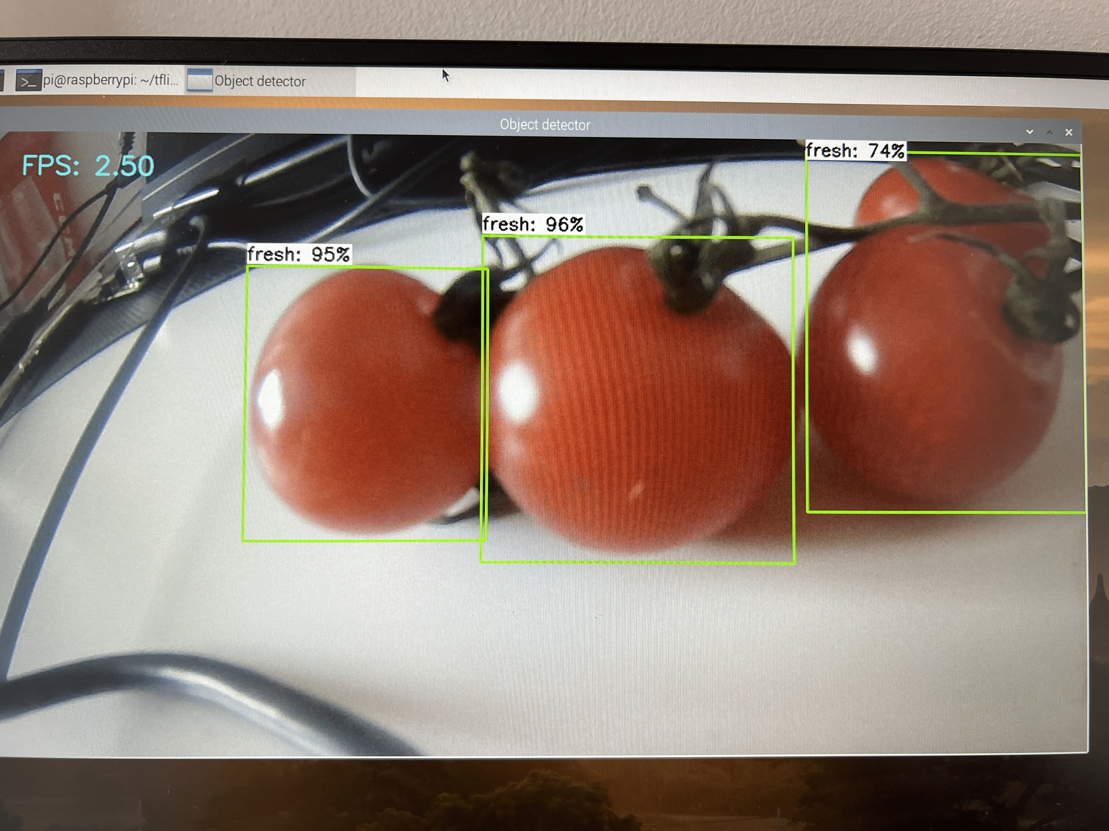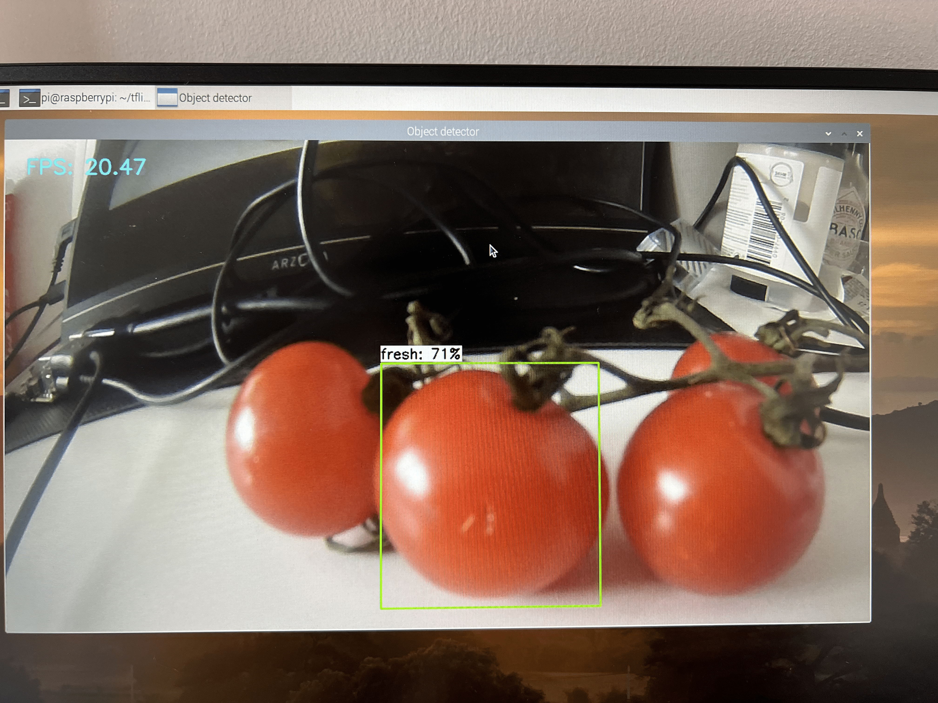Image 1 Image 2

Further testing was conducted using the step in for the unripe and rotten classes, using the different methods of running the mode the result below shows similar results as previous tests where the images 3 and 4 are the model being ran on the CPU of the Raspberry pi 4B and Images 5 and 6 are the model running with the TPU Co-processor. The images show the similar results to the first test where the model on the CPU is detecting more classes within the image with higher confidence unlike the TPU is only detecting 1 class and during the test it struggled detecting the yellow tomato as unripe at all it would only give the class fresh or rotten due to the marker. The marker was to indicate surface damage and rotting both models could detect this as a different class it did have issues when jumping between either rotten or another class, this is probably due to the subject not being like the dataset of rotten tomatoes.

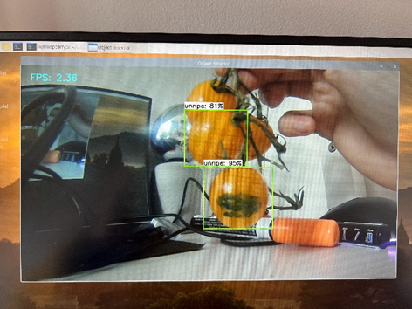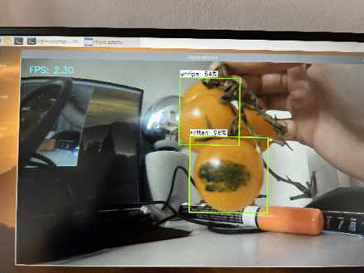 Image 3 Image4

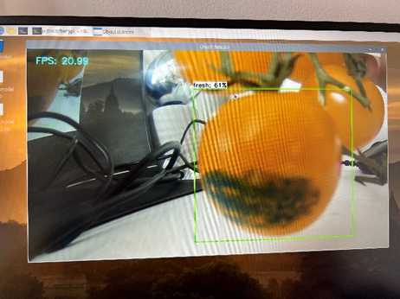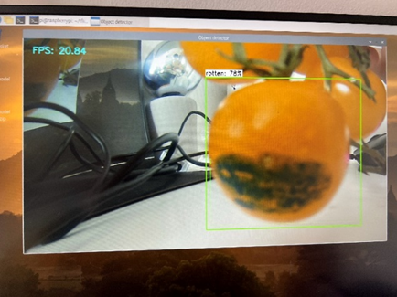Image 5 Image 6

In conclusion from these images the clear assumption can be made that the slower model may be running slower but generated more accurate and optimal results, this is probably due to the model being able to estimate features in the frame and complete inferencing at a more stable rate and not getting overloaded with frames. Whereas the TPU Ran fast and somewhat accurate with the fresh Tomato, but it would struggle with finding more than 1 class in an image and would produce sub-optimal results. The clear comparison is that the TPU can certainly be used to speedup machine learning by a lot however it can take an effect on the accuracy when in application.

**Improvement for future study.**

Within this section of the report the mistakes and accidents will be covered, along with their remedies and further improvements that should be made to this project for it to Aline completely with the objective of the project. Firstly, the initial development board (Coral Dev board) did not interact with the peripheral camera and the GPIO configuration library would not install, this may be due to the fault of the user however the documentation for the development board was lacking and not specific in troubleshooting issues. This was remedied by using the Raspberry pi 4b along with the coral USB accelerator, unfortunately this made an impact on timing due to low stock and shipping issues. Another issue that causes a lot was that a lot of the packages used an outdated version of Python that was not available on supported Raspbian OS, the attempted remedy was Install the version of python need however this caused more conflicts between libraries and packages. The final solution was to use an unsupported version of Raspbian Buster this worked with all the package as it was launched around the same time as the Coral, The Coral and TPU hardware did not have as much support as assumed there would be it seemed to have not been updated for later distribution of python or Raspbian. For improvements on the system the model should be trained again with a more accurate and balanced dataset curated in person in the environment for the application, the model also needs to be accurately optimised for the TPU allowing to be fast and keep the accuracy found in the slower model. For future Improve the Coral TPU is having a secondary release with ASUS IoT hardware that will have updated packages and more support than what it has now [Google Developer blog].

**Reference List**

Brinkley, C. and S. Kingsley, J. (2016). Urban Agriculture - an overview | ScienceDirect Topics. [online] www.sciencedirect.com. Available at: https://www.sciencedirect.com/topics/agricultural-and-biological-sciences/urban-agriculture.

Coral. (n.d.). Get started with the Dev Board. [online] Available at: https://coral.ai/docs/dev-board/get-started/.

Google Cloud. (n.d.). Introduction to Cloud TPU. [online] Available at: https://cloud.google.com/tpu/docs/intro-to-tpu.

Kim, T., Lee, D.-H., Kim, K.-C., Choi, T. and Jun Myoung Yu (2022). Tomato Maturity Estimation Using Deep Neural Network. Tomato Maturity Estimation Using Deep Neural Network, 13(1), pp.412–412. doi:https://doi.org/10.3390/app13010412.

Liakos, K.G., Busato, P., Moshou, D., Pearson, S. and Bochtis, D. (2018). Machine Learning in Agriculture: A Review. Sensors (Basel, Switzerland), [online] 18(8), p.2674. doi:https://doi.org/10.3390/s18082674.

Tillett, R.D. (1991). Image analysis for agricultural processes: a review of potential opportunities. Journal of Agricultural Engineering Research, 50, pp.247–258. doi:https://doi.org/10.1016/s0021-8634(05)80018-6.

Koul, A., Siddha Ganju and Meher Kasam (2019). Practical Deep Learning for Cloud, Mobile, and Edge. O’Reilly Media.

roboflow.com. (n.d.). *MobileNet SSD v2 Object Detection Model*. [online] Available at: <https://roboflow.com/model/mobilenet-ssd-v2#:~:text=MobileNetSSDv2%20(MobileNet%20Single%20Shot%20Detector>.

Coral. (2020). *TensorFlow models on the Edge TPU*. [online] Available at: https://coral.ai/docs/edgetpu/models-intro/#transfer-learning [Accessed 26 Mar. 2024].

TensorFlow. (2019). *TensorFlow Lite  |  TensorFlow Lite  |  TensorFlow*. [online] Available at: https://www.tensorflow.org/lite.

Jonnala, H., Wang, M. and Brooks, M. (2024). google-coral/example-object-tracker. [online] GitHub. Available at: https://github.com/google-coral/example-object-tracker [Accessed 21 Dec. 2023].

Juras Evans(2023). Train_TFLite2_Object_Detection_Model. [Online] Google Colab. Available at: <https://colab.research.google.com/drive/1GnFlFsptH81Dz73w9SBtRiINx17xGqdt#scrollTo=fF8ysCfYKgTP> [accessed 3 Feb,2023].

Raspberry Pi (n.d.). Raspberry Pi 4 Model B specifications. [online] Raspberry Pi. Available at: <https://www.raspberrypi.com/products/raspberry-pi-4-model-b/specifications/>.

GoogleDeveloperblog. (n.d.). Coral, Google’s platform for Edge AI, chooses ASUS as OEM partner for global scale. [online] Available at: https://developers.googleblog.com/2022/05/coral-googles-platform-for-edge-ai.html [Accessed 26 Mar. 2024].

**Appendix**

Colab Notebook

<https://colab.research.google.com/drive/1GnFlFsptH81Dz73w9SBtRiINx17xGqdt#scrollTo=fF8ysCfYKgTP>

Python code

=(1920,1080),framerate=30):

# Initialize the PiCamera and the camera image stream

self.stream = cv2.VideoCapture(0)

ret = self.stream.set(cv2.CAP_PROP_FOURCC, cv2.VideoWriter_fourcc(*'MJPG'))

ret = self.stream.set(3,resolution[0])

ret = self.stream.set(4,resolution[1])

# Read first frame from the stream

(self.grabbed, self.frame) = self.stream.read()

# Variable to control when the camera is stopped

self.stopped = False

def start(self):

# Start the thread that reads frames from the video stream

Thread(target=self.update,args=()).start()

return self

def update(self):

# Keep looping indefinitely until the thread is stopped

while True:

# If the camera is stopped, stop the thread

if self.stopped:

# Close camera resources

self.stream.release()

return

# Otherwise, grab the next frame from the stream

(self.grabbed, self.frame) = self.stream.read()

def read(self):

# Return the most recent frame

return self.frame

def stop(self):

# Indicate that the camera and thread should be stopped

self.stopped = True

# Define and parse input arguments

parser = argparse.ArgumentParser()

parser.add_argument('--modeldir', help='Folder the .tflite file is located in',

required=True)

parser.add_argument('--graph', help='Name of the .tflite file, if different than detect.tflite',

default='detect.tflite')

parser.add_argument('--labels', help='Name of the labelmap file, if different than labelmap.txt',

default='labelmap.txt')

parser.add_argument('--threshold', help='Minimum confidence threshold for displaying detected objects',

default=0.5)

parser.add_argument('--resolution', help='Desired webcam resolution in WxH. If the webcam does not support the resolution entered, errors may occur.',

default='1280x720')

parser.add_argument('--edgetpu', help='Use Coral Edge TPU Accelerator to speed up detection',

action='store_true')

args = parser.parse_args()

MODEL_NAME = args.modeldir

GRAPH_NAME = args.graph

LABELMAP_NAME = args.labels

min_conf_threshold = float(args.threshold)

resW, resH = args.resolution.split('x')

imW, imH = int(resW), int(resH)

use_TPU = args.edgetpu

# Import TensorFlow libraries

# If tflite_runtime is installed, import interpreter from tflite_runtime, else import from regular tensorflow

# If using Coral Edge TPU, import the load_delegate library

pkg = importlib.util.find_spec('tflite_runtime')

if pkg:

from tflite_runtime.interpreter import Interpreter

if use_TPU:

from tflite_runtime.interpreter import load_delegate

else:

from tensorflow.lite.python.interpreter import Interpreter

if use_TPU:

from tensorflow.lite.python.interpreter import load_delegate

# If using Edge TPU, assign filename for Edge TPU model

if use_TPU:

# If user has specified the name of the .tflite file, use that name, otherwise use default 'edgetpu.tflite'

if (GRAPH_NAME == 'detect.tflite'):

GRAPH_NAME = 'edgetpu.tflite'

# Get path to current working directory

CWD_PATH = os.getcwd()

# Path to .tflite file, which contains the model that is used for object detection

PATH_TO_CKPT = os.path.join(CWD_PATH,MODEL_NAME,GRAPH_NAME)

# Path to label map file

PATH_TO_LABELS = os.path.join(CWD_PATH,MODEL_NAME,LABELMAP_NAME)

# Load the label map

with open(PATH_TO_LABELS, 'r') as f:

labels = [line.strip() for line in f.readlines()]

#label map fix for smaple tflite model as the first label needs to be deleted.

if labels[0] == '???':

del(labels[0])

# Load the Tensorflow Lite model.

# If using Edge TPU, use special load_delegate argument

if use_TPU:

interpreter = Interpreter(model_path=PATH_TO_CKPT,

experimental_delegates=[load_delegate('libedgetpu.so.1.0')])

print(PATH_TO_CKPT)

else:

interpreter = Interpreter(model_path=PATH_TO_CKPT)

interpreter.allocate_tensors()

# Get model details

input_details = interpreter.get_input_details()

output_details = interpreter.get_output_details()

height = input_details[0]['shape'][1]

width = input_details[0]['shape'][2]

floating_model = (input_details[0]['dtype'] == np.float32)

input_mean = 127.5

input_std = 127.5

# Check output layer name to determine if this model was created with TF2 or TF1,

# because outputs are ordered differently for TF2 and TF1 models

outname = output_details[0]['name']

if ('StatefulPartitionedCall' in outname): # This is a TF2 model

boxes_idx, classes_idx, scores_idx = 1, 3, 0

else: # This is a TF1 model

boxes_idx, classes_idx, scores_idx = 0, 1, 2

# Initialize frame rate calculation

frame_rate_calc = 1

freq = cv2.getTickFrequency()

# Initialize video stream

videostream = VideoStream(resolution=(imW,imH),framerate=30).start()

time.sleep(1)

#for frame1 in camera.capture_continuous(rawCapture, format="bgr",use_video_port=True):

while True:

found_match = False #found match varible for peripheral output.

# Start timer (for calculating frame rate)

t1 = cv2.getTickCount()

# Grab frame from video stream

frame1 = videostream.read()

# Acquire frameresize to expected shape [1xHxWx3]

frame = frame1.copy()

frame_rgb = cv2.cvtColor(frame, cv2.COLOR_BGR2RGB)#change the format of tyhe image as tflite needs rgb

frame_resized = cv2.resize(frame_rgb, (width, height)) #resize to expected shape [1xHxWx3]

input_data = np.expand_dims(frame_resized, axis=0)#varible of input frames as images

# normalize pixel values if using a floating model which has not be quantized to 8bit integers

if floating_model:

input_data = (np.float32(input_data) - input_mean) / input_std

# actual detection by running the model with the image as input

interpreter.set_tensor(input_details[0]['index'],input_data)

interpreter.invoke()

# Retrieve detection results

boxes = interpreter.get_tensor(output_details[boxes_idx]['index'])[0] # Bounding box coordinates of detected objects

classes = interpreter.get_tensor(output_details[classes_idx]['index'])[0] # Class index of detected objects

scores = interpreter.get_tensor(output_details[scores_idx]['index'])[0] # Confidence of detected objects

# Loop over all detections and draw detection box if confidence is above minimum threshold

for i in range(len(scores)):

if ((scores[i] > min_conf_threshold) and (scores[i] <= 1.0)):

# Get bounding box coordinates and draw box

# Interpreter can return coordinates that are outside of image dimensions, need to force them to be within image using max() and min()

ymin = int(max(1,(boxes[i][0] * imH)))

xmin = int(max(1,(boxes[i][1] * imW)))

ymax = int(min(imH,(boxes[i][2] * imH)))

xmax = int(min(imW,(boxes[i][3] * imW)))

cv2.rectangle(frame, (xmin,ymin), (xmax,ymax), (10, 255, 0), 2)

# Draw label

object_name = labels[int(classes[i])] # Look up object name from "labels" array using class index

label = '%s: %d%%' % (object_name, int(scores[i]*100)) # Example: 'person: 72%'

labelSize, baseLine = cv2.getTextSize(label, cv2.FONT_HERSHEY_SIMPLEX, 0.7, 2) # Get font size

label_ymin = max(ymin, labelSize[1] + 10) # Make sure not to draw label too close to top of window

cv2.rectangle(frame, (xmin, label_ymin-labelSize[1]-10), (xmin+labelSize[0], label_ymin+baseLine-10), (255, 255, 255), cv2.FILLED) # Draw white box to put label text in

cv2.putText(frame, label, (xmin, label_ymin-7), cv2.FONT_HERSHEY_SIMPLEX, 0.7, (0, 0, 0), 2) # Draw label text

if (object_name == labels[int(classes[i])]) and (scores[i]>=0.80):

print (label)

# Draw framerate in corner of frame

cv2.putText(frame,'FPS: {0:.2f}'.format(frame_rate_calc),(30,50),cv2.FONT_HERSHEY_SIMPLEX,1,(255,255,0),2,cv2.LINE_AA)

# All the results have been drawn on the frame, so it's time to display it.

cv2.imshow('Object detector', frame)

# Calculate framerate

t2 = cv2.getTickCount()

time1 = (t2-t1)/freq

frame_rate_calc= 1/time1

# Press 'q' to quit

if cv2.waitKey(1) == ord('q'):

break

# Clean up

cv2.destroyAllWindows()

videostream.stop()

Training configuration.

# SSD with Mobilenet v2

# Trained on COCO17, initialized from Imagenet classification checkpoint

# Train on TPU-8

#

# Achieves 22.2 mAP on COCO17 Val

model {

ssd {

inplace_batchnorm_update: true

freeze_batchnorm: false

num_classes: 3

box_coder {

faster_rcnn_box_coder {

y_scale: 10.0

x_scale: 10.0

height_scale: 5.0

width_scale: 5.0

}

}

matcher {

argmax_matcher {

matched_threshold: 0.5

unmatched_threshold: 0.5

ignore_thresholds: false

negatives_lower_than_unmatched: true

force_match_for_each_row: true

use_matmul_gather: true

}

}

similarity_calculator {

iou_similarity {

}

}

encode_background_as_zeros: true

anchor_generator {

ssd_anchor_generator {

num_layers: 6

min_scale: 0.2

max_scale: 0.95

aspect_ratios: 1.0

aspect_ratios: 2.0

aspect_ratios: 0.5

aspect_ratios: 3.0

aspect_ratios: 0.3333

}

}

image_resizer {

fixed_shape_resizer {

height: 300

width: 300

}

}

box_predictor {

convolutional_box_predictor {

min_depth: 0

max_depth: 0

num_layers_before_predictor: 0

use_dropout: false

dropout_keep_probability: 0.8

kernel_size: 1

box_code_size: 4

apply_sigmoid_to_scores: false

class_prediction_bias_init: -4.6

conv_hyperparams {

activation: RELU_6,

regularizer {

l2_regularizer {

weight: 0.00004

}

}

initializer {

random_normal_initializer {

stddev: 0.01

mean: 0.0

}

}

batch_norm {

train: true,

scale: true,

center: true,

decay: 0.97,

epsilon: 0.001,

}

}

}

}

feature_extractor {

type: 'ssd_mobilenet_v2_keras'

min_depth: 16

depth_multiplier: 1.0

conv_hyperparams {

activation: RELU_6,

regularizer {

l2_regularizer {

weight: 0.00004

}

}

initializer {

truncated_normal_initializer {

stddev: 0.03

mean: 0.0

}

}

batch_norm {

train: true,

scale: true,

center: true,

decay: 0.97,

epsilon: 0.001,

}

}

override_base_feature_extractor_hyperparams: true

}

loss {

classification_loss {

weighted_sigmoid_focal {

alpha: 0.75,

gamma: 2.0

}

}

localization_loss {

weighted_smooth_l1 {

delta: 1.0

}

}

classification_weight: 1.0

localization_weight: 1.0

}

normalize_loss_by_num_matches: true

normalize_loc_loss_by_codesize: true

post_processing {

batch_non_max_suppression {

score_threshold: 1e-8

iou_threshold: 0.6

max_detections_per_class: 100

max_total_detections: 100

}

score_converter: SIGMOID

}

}

}

train_config: {

fine_tune_checkpoint_version: V2

fine_tune_checkpoint: "/content/models/mymodel/ssd_mobilenet_v2_320x320_coco17_tpu-8/checkpoint/ckpt-0"

fine_tune_checkpoint_type: "detection"

batch_size: 16

sync_replicas: true

startup_delay_steps: 0

replicas_to_aggregate: 8

num_steps: 40000

data_augmentation_options {

random_horizontal_flip {

}

}

data_augmentation_options {

ssd_random_crop {

}

}

optimizer {

momentum_optimizer: {

learning_rate: {

cosine_decay_learning_rate {

learning_rate_base: .08

total_steps: 50000

warmup_learning_rate: .026666

warmup_steps: 2000

}

}

momentum_optimizer_value: 0.9

}

use_moving_average: false

}

max_number_of_boxes: 100

unpad_groundtruth_tensors: false

}

train_input_reader: {

label_map_path: "/content/labelmap.pbtxt"

tf_record_input_reader {

input_path: "/content/train.tfrecord"

}

}

eval_config: {

metrics_set: "coco_detection_metrics"

use_moving_averages: false

}

eval_input_reader: {

label_map_path: "/content/labelmap.pbtxt"

shuffle: false

num_epochs: 1

tf_record_input_reader {

input_path: "/content/val.tfrecord"

}

}